**PANCAKE BREAKFAST**

**Red Mount UMC**

**1883 Baltimore Pike, East Berlin**

**Saturday, November 11th**

**7 – 11 AM**

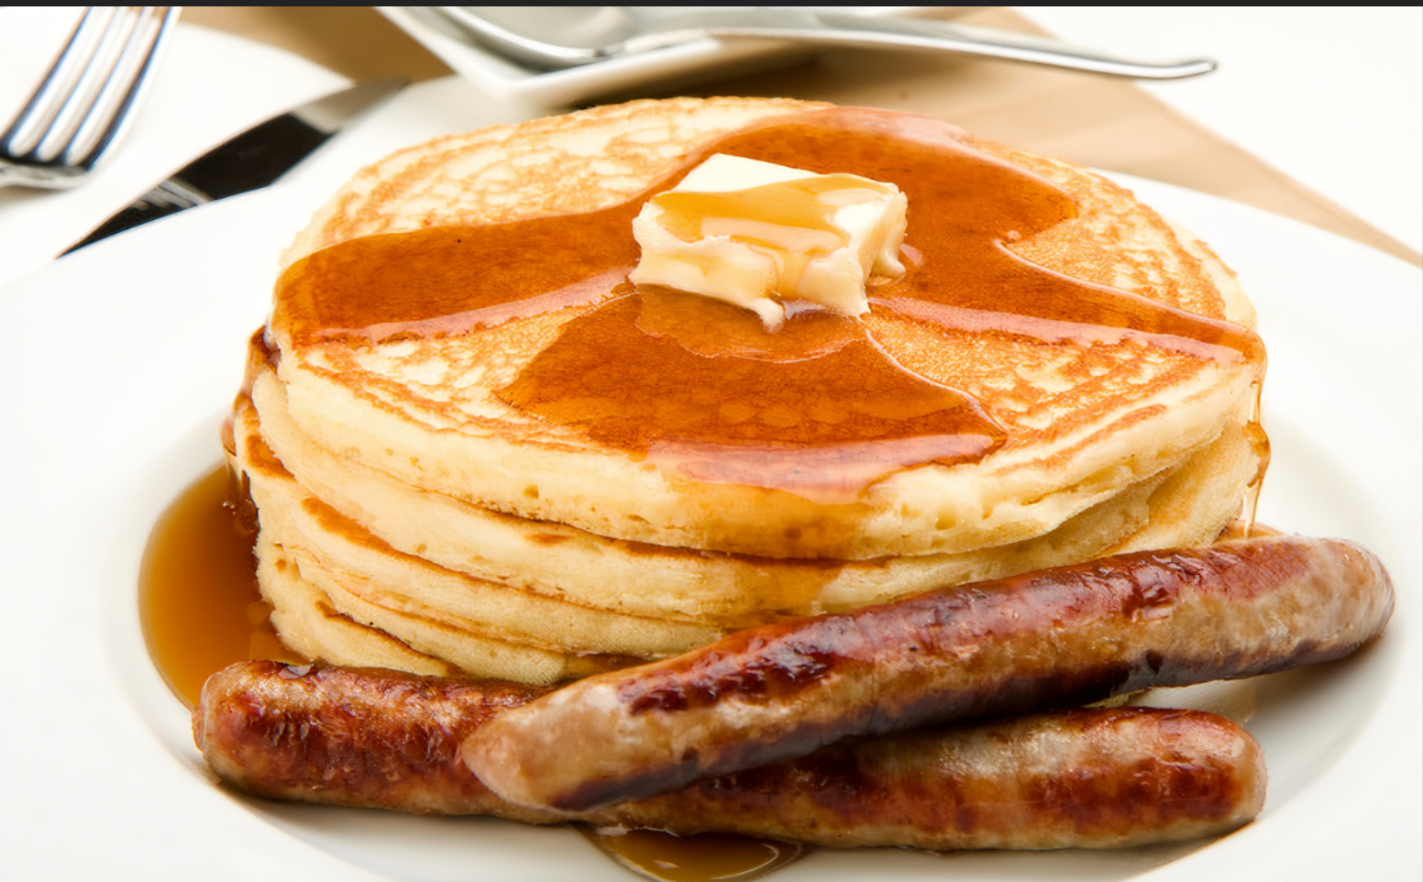

**Adults $7- Children $3 - Veterans Free**